The Fourth Sunday of Easter
April 21, 2024

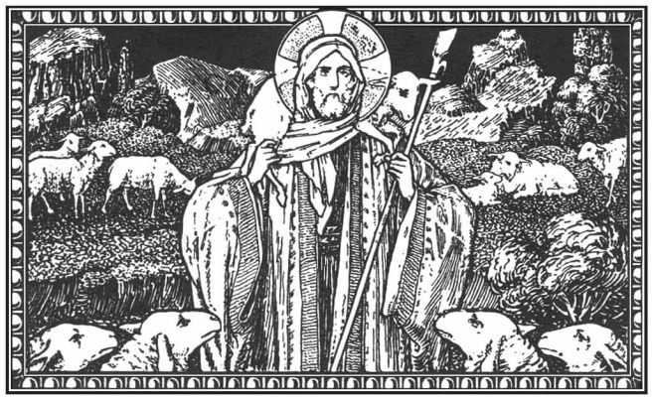

Trinity Episcopal Mission
14519 Church Street
Upper Marlboro, MD 20773
301-627-2636

The Right Rev. Marianne E. Budde
Bishop of Washington

The Rev. Dr. Peter Antoci, Vicar
301-627-2636

The Rev. Dr. Thomas Bauer, Chaplain
410-629-9435

The Fourth Sunday of Easter
Holy Eucharist
April 21, 2024

WELCOME TO CHURCH TODAY!

Call to Worship: Bells
The church bell calls us to worship

Procession

Prelude

The procession enters while we sing.
Opening Hymn Come Thou Fount LEVAS 111

Acclamation

Alleluia! Christ is risen.
The Lord is risen indeed. Alleluia!

Collect for Purity
Almighty God, to you all hearts are open, all desires known, and from you no secrets are hid: Cleanse the thoughts of our hearts by the inspiration of your Holy Spirit, that we may perfectly love you, and worthily magnify your holy Name; through Christ our Lord. Amen.

The Peace

Presider: The peace of the risen Lord Jesus be with you.
People: And also with you.

Song of Praise
The following is sung.

Prayer of the Day
The Lord be with you. And also with you. Let us pray.
O God, whose Son Jesus is the good shepherd of your people: Grant that when we hear his voice we may know him who calls us each by name, and follow where he leads; who, with you and the Holy Spirit, lives and reigns, one God, for ever and ever. Amen.

First Reading Acts 4:5-12 Janet Ellmore
A reading from the book of Acts.
The rulers, elders, and scribes assembled in Jerusalem, with Annas the high priest, Caiaphas, John, and Alexander, and all who were of the high-priestly family. When they had made the prisoners stand in their midst, they inquired, "By what power or by what name did you do this?" Then Peter, filled with the Holy Spirit, said to them, "Rulers of the people and elders, if we are questioned today because of a good deed done to someone who was sick and are asked how this man has been healed, let it be known to all of you, and to all the people of Israel, that this man is standing before you in good health by the name of Jesus Christ of Nazareth, whom you crucified, whom God raised from the dead. This Jesus is `the stone that was rejected by you, the builders; it has become the cornerstone.' There is salvation in no one else, for there is no other name under heaven given among mortals by which we must be saved." The Word of the Lord. Thanks be to God.

Psalter Psalm 23 Molly McCarty
O God, you are my shepherd; I shall not be in want. You make me lie down in green pastures and lead me beside still waters.

You revive my soul and guide me along right pathways for the sake of your Name. Though I walk through the valley of the shadow of death, I shall fear no evil, for you are with me; your rod and your staff, they comfort me.

You spread a table before me in the presence of those who trouble me; you have anointed my head with oil, and my cup is running over. Surely your goodness and mercy shall follow me all the days of my life, and I will dwell in the house of God for ever.

Second Reading 1 John 3:16-24 Pat Smith
A reading from the first letter of John.
We know love by this, that he laid down his life for us-- and we ought to lay down our lives for one another. How does God's love abide in anyone who has the world's goods and sees a brother or sister in need and yet refuses help? Little children, let us love, not in word or speech, but in truth and action. And by this we will know that we are from the truth and will reassure our hearts before him whenever our hearts condemn us; for God is greater than our hearts, and he knows everything. Beloved, if our hearts do not condemn us, we have boldness before God; and we receive from him whatever we ask, because we obey his commandments and do what pleases him. And this is his commandment, that we should believe in the name of his Son Jesus Christ and love one another, just as he has commanded us. All who obey his commandments abide in him, and he abides in them. And by this we know that he abides in us, by the Spirit that he has given us.
The Word of the Lord. Thanks be to God.

Sequence Hymn Christ is Alive H 182 (Verses1&2)

Holy Gospel John 10:11-18
The Holy Gospel of our Lord Jesus Christ according to John.
Glory to you, Lord Christ.
Jesus said, “I am the good shepherd. The good shepherd lays down his life for the sheep. The hired hand, who is not the shepherd and does not own the sheep, sees the wolf coming and leaves the sheep and runs away—and the wolf snatches them and scatters them. The hired hand runs away because a hired hand does not care for the sheep. I am the good shepherd. I know my own and my own know me, just as the Father knows me and I know the Father. And I lay down my life for the sheep. I have other sheep that do not belong to this fold. I must bring them also, and they will listen to my voice. So there will be one flock, one shepherd. For this reason the Father loves me, because I lay down my life in order to take it up again. No one takes it from me, but I lay it down of my own accord. I have power to lay it down, and I have power to take it up again. I have received this command from my Father.” The Gospel of the Lord. Praise to you, Lord Christ.

Sequence Hymn Christ is Alive H 182 (Verses 3-5)

Sermon The Reverend Dr. Thomas Bauer
A time of silent reflection.

The Apostles Creed
All stand and together say
I believe in God, the Father almighty, creator of heaven and earth. I believe in Jesus Christ, his only Son, our Lord. He was conceived by the power of the Holy Spirit and born of the Virgin Mary. He suffered under Pontius Pilate, was crucified, died, and was buried. He descended to the dead. On the third day he rose again. He ascended into heaven, and is seated at the right hand of the Father. He will come again to judge the living and the dead. I believe in the Holy Spirit, the holy catholic Church, the communion of saints, the forgiveness of sins, the resurrection of the body, and the life everlasting. Amen.

Prayers of the People Beverly Wells
Presider: We bring our prayers before God on behalf of the world and in the light of Christ’s resurrection.

Lector:
Almighty One, fill your Church with life and empower us with Christ’s love. Raise us by your Spirit: That we may live in the power of Christ’s resurrection.

Living God, you have triumphed over evil and death, bringing hope to all the world. Speak truth to those who lead and hold authority among the nations: That they may be agents of life and peace.

O God, you show no partiality, and accept all who live justly. Let your compassion extend to every person, that the power of evil and injustice may be banished: And all people may live as your beloved children.

May the power of the resurrection bring healing and hope to those for whom we pray, especially those on our prayer list and those we name now Susan Quade, Charlie Butler, Doug Buyer, Norma Coffren, Mary Alice Davis, Pat Fitzgerald, Lori Harding, Ruth Hopkins, Randy Nelson Housden, Jerry Johnson, Maxine Jones, Priscilla Lyons, Joe McCarty, Carol Richardson, Marisa Salavar, Annette Sardelli, Michael Sardelli, Anne Sasscer, Malcolm Shaw, Judy Waller, Penny Bing, Carolyn Goggins, Gregory Goggins, Jerry Smith, Jennifer Corado and Barbara Jenkins, the People of Ukraine, our beloved Trinity Episcopal Mission, and those we wish to name aloud now (members of the congregation may offer their own petitions) We pray: May Christ the wounded healer overcome all that threatens us.

We offer our grateful gladness this day for all God’s gifts. Give thanks to the Lord who is good: Whose mercy endures forever.

Christ has died and is risen, trampling down the power of death. We remember those who have died, especially those on our prayer list, and those we would like to name now … … May their dwelling be with God: And may they share in the risen life of Christ Jesus.

Presider: Eternal God, you have anointed Jesus of Nazareth with the Holy Spirit and power, and raised him from death: make our lives one with his in this Eucharist, that we may be witnesses to his work of reconciliation and peace, through Jesus Christ our Savior. Amen.

The Holy Communion
The Presider says: On this day the Lord has acted;
We will rejoice and be glad in it. (Psalm 118:24)

Offertory My Faith Looks up to Thee LEVAS 88

Representatives of the congregation bring the people's offerings of bread and wine, and money or other gifts, to the Presider or Presider. The people stand while the offerings are presented and placed on the altar. All stand and sing the Doxology.

Praise God, from whom all blessings flow; Praise God, all creatures, here below; Praise God above, ye heavenly host; Praise Father, Son and Holy Ghost. Amen.

The Great Thanksgiving
The people remain standing
The Lord be with you.
And also with you.
Lift up your hearts.
We lift them to the Lord.
Let us give thanks to the Lord our God.
It is right to give God thanks and praise.

All thanks and praise are yours at all times and in all places, our true and loving God; through Jesus Christ, your eternal Word, the Wisdom from on high by whom you created all things. You laid the foundations of the world and enclosed the sea when it burst out from the womb; You brought forth all creatures of the earth and gave breath to humankind. Wondrous are you, Holy One of Blessing, all you create is a sign of hope for our journey; And so as the morning stars sing your praises we join the heavenly beings and all creation as we shout with joy:

Sanctus

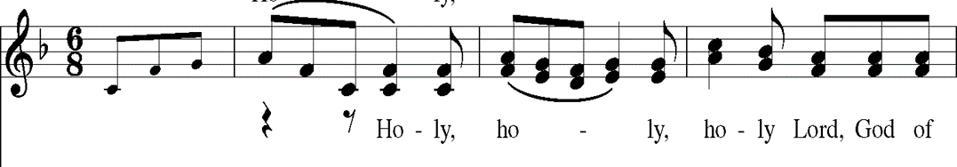

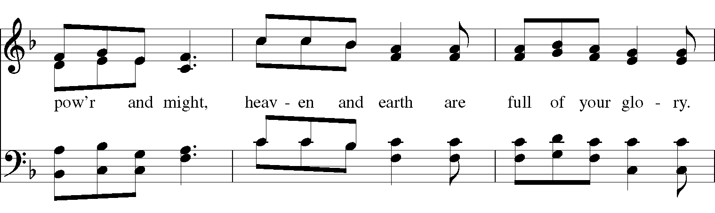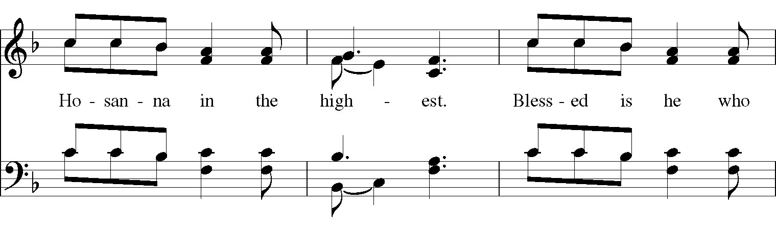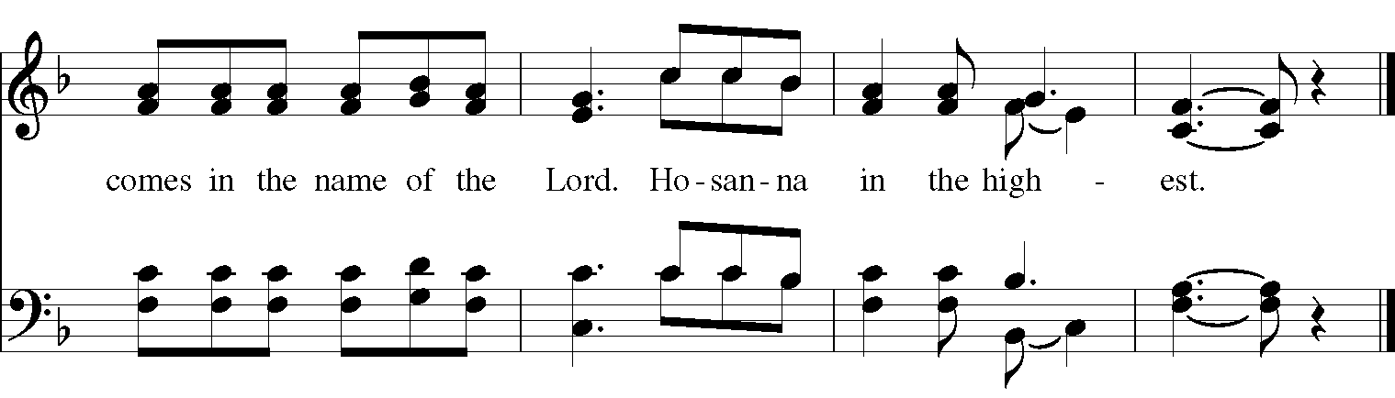
The people stand or kneel. The Presider continues
Glory and honor are yours, Creator of all, your Word has never been silent; you called a people to yourself, as a light to the nations, you delivered them from bondage and led them to a land of promise. Of your grace, you gave Jesus to be human, to share our life, to proclaim the coming of your holy reign and give himself for us, a fragrant offering. Through Jesus Christ our Redeemer, you have freed us from sin, brought us into your life, reconciled us to you, and restored us to the glory you intend for us.

We thank you that on the night before he died for us Jesus took bread, and when he had given thanks to you, he broke it, gave it to his friends and said: “Take, eat, this is my Body, broken for you. Do this for the remembrance of me.” After supper Jesus took the cup of wine, said the blessing, gave it to his friends and said: “Drink this, all of you: this cup is the new Covenant in my Blood, poured out for you and for all for the forgiveness of sin. Do this for the remembrance of me.” And so, remembering all that was done for us: the cross, the tomb, the resurrection and ascension, longing for Christ’s coming in glory, and presenting to you these gifts your earth has formed, and human hands have made, we acclaim you, O Christ:
Dying, you destroyed our death.
Rising, you restored our life.
Christ Jesus, come in glory!
Send your Holy Spirit upon us and upon these gifts of bread and wine that they may be to us the Body and Blood of your Christ. Grant that we, burning with your Spirit’s power, may be a people of hope, justice, and love. Giver of Life, draw us together in the Body of Christ, and in the fullness of time gather us with all your people into the joy of our true eternal home. Through Christ and with Christ and in Christ, by the inspiration of your Holy Spirit, we worship you our God and Creator in voices of unending praise.
. (Sing Once)

And now, as our Savior Christ has taught us, we are bold to pray:

People and Presider:
Our Father, who art in heaven, hallowed be thy Name, thy kingdom come, thy will be done, on earth as it is in heaven. Give us this day our daily bread. And forgive us our trespasses, as we forgive those who trespass against us. And lead us not into temptation,
but deliver us from evil. For thine is the kingdom, and the power, and the glory, for ever and ever. Amen.

The Breaking of the Bread
A period of silence is kept.

Alleluia. Christ our Passover is sacrificed for us;
Therefore let us keep the feast. Alleluia.

The following is sung:

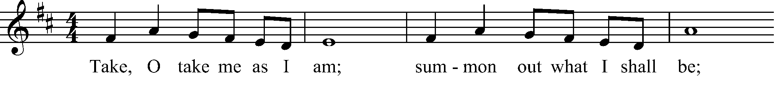
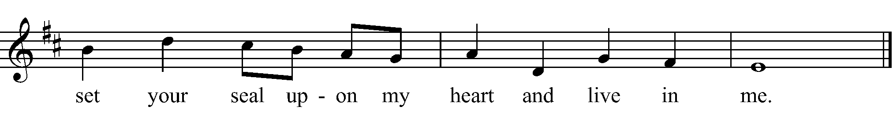

The Presider invites everyone to receive Communion.
The Gifts of God for the People of God. Take them in remembrance that Christ lived, died, and rose for you, and feed on him in your hearts by faith, with thanksgiving.
All who seek God and a deeper life in Christ are welcome to receive Holy Communion. At the direction of an usher, please exit your pew and receive the bread first, then proceed to the wine, and on to the water; then return to your seat. Communion may also be received in the bread alone, or in the bread and the wine with your small glass (one is provided if you need one). Please receive the bread first and consume it. If you are receiving the wine, please let the minister pour it into your glass, consume it, and then proceed to purify your glass with water, and consume that too. If you are at home, you are invited to receive Communion from the Reserved Sacrament at this time. If you would prefer to receive a blessing instead of Communion, simply cross your arms over your heart and the Presider will bless you. Gluten-free wafers are available; just ask the Presider for one.

Communion Hymn I Come to the Garden Alone LEVAS 69
After Communion, the Presider says:
Let us pray.

Prayer after Communion
Presider and People:
Eternal God, you have graciously accepted us as living members of your Son our Savior Jesus Christ, and you have fed us with spiritual food in the Sacrament of his Body and Blood. Send us now into the world in peace, and grant us strength and courage to love and serve you with gladness and singleness of heart; through Christ our Lord. Amen.

Blessings and Thanksgivings

Presider: At this time, I invite you forward if you are celebrating a Birthday, Anniversary or any other blessing.

Presider: O God, our times are in your hands: Look with favor, we pray, on your servants, as they give thanks for your grace in their lives. Grant that they may grow in wisdom and strength, and increase their trust in your goodness in all the days to come, through Jesus Christ our Lord. Amen.

Announcements

Congregational Blessing (Sung once by all)
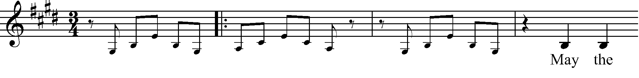
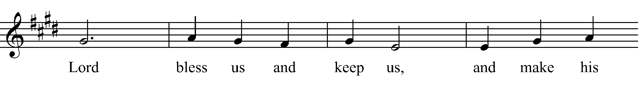
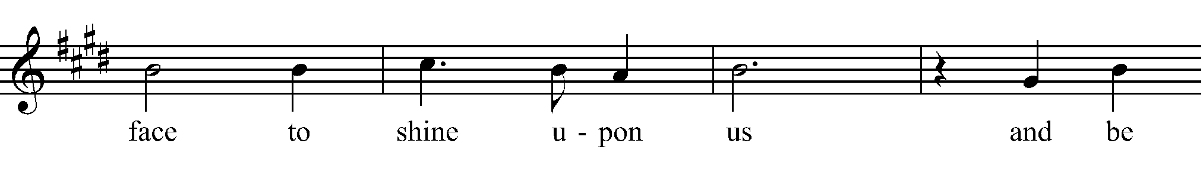
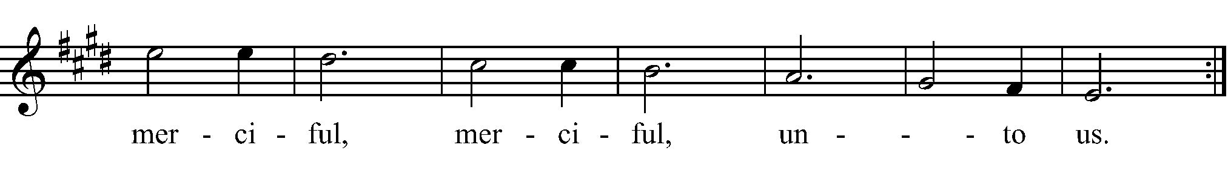

Post Communion Hymn Just a Closer Walk with Thee LEVAS 72

Dismissal

Presider: Alleluia! Let us go forth to love and serve the Lord.
Thanks be to God. Alleluia!

Created using riteworship. All musical selections reprinted with the permission of ritesong. All rights reserved. Used with permission. All scripture passages are taken from the New Revised Standard Version Bible, copyright 1989, Division of Christian Education of the National Council of the Churches of Christ in the United States of America. Used by permission. All rights reserved.

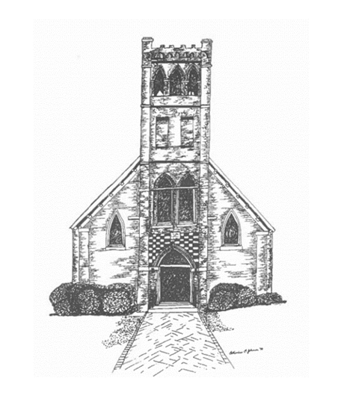

Trinity Mission
P.O. Box 187, 14515 Church Street, Upper Marlboro, MD 20773
Phone: (301)627-2636

The Rev. Dr. Peter M. Antoci, Vicar
The Rev. Dr. Thomas Bauer, Chaplain
Armand Peterson, Director of Music
Janet Ellmore, Musician
Leonard Blair, Screening

