The Fifth Sunday of Easter
April 28, 2024

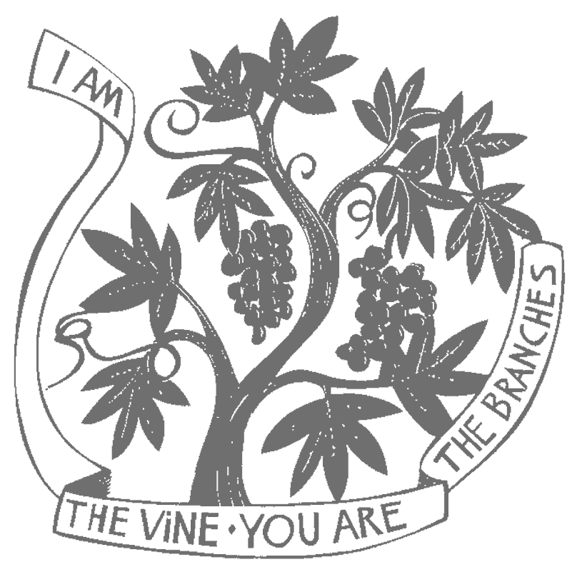

Trinity Episcopal Mission
14519 Church Street
Upper Marlboro, MD 20773
301-627-2636

The Right Rev. Marianne E. Budde
Bishop of Washington

The Rev. Dr. Peter Antoci, Vicar
301-627-2636

The Rev. Dr. Thomas Bauer, Chaplain
410-629-9435

The Fifth Sunday of Easter
Holy Eucharist
April 28, 2024

WELCOME TO CHURCH TODAY!

Call to Worship: Bells
The church bell calls us to worship

Procession

Prelude

The procession enters while we sing.
Opening Hymn Love Divine All Loves Excelling H 657
Acclamation

Alleluia! Christ is risen.
The Lord is risen indeed. Alleluia!

Collect for Purity
Almighty God, to you all hearts are open, all desires known, and from you no secrets are hid: Cleanse the thoughts of our hearts by the inspiration of your Holy Spirit, that we may perfectly love you, and worthily magnify your holy Name; through Christ our Lord. Amen.

The Peace

Presider: The peace of the risen Lord Jesus be with you.
People: And also with you.

Song of Praise
The following is sung.

Prayer of the Day
The Lord be with you. And also with you. Let us pray.
Almighty God, whom truly to know is everlasting life: Grant us so perfectly to know your Son Jesus Christ to be the way, the truth, and the life, that we may steadfastly follow his steps in the way that leads to eternal life; through Jesus Christ your Son our Lord, who lives and reigns with you, in the unity of the Holy Spirit, one God, for ever and ever. Amen.

First Reading Acts 8:26-40 Jackie Belton
A reading from the book of Acts.
An angel of the Lord said to Philip, “Get up and go toward the south to the road that goes down from Jerusalem to Gaza.” (This is a wilderness road.) So he got up and went. Now there was an Ethiopian eunuch, a court official of the Candace, queen of the Ethiopians, in charge of her entire treasury. He had come to Jerusalem to worship and was returning home; seated in his chariot, he was reading the prophet Isaiah. Then the Spirit said to Philip, “Go over to this chariot and join it.” So Philip ran up to it and heard him reading the prophet Isaiah. He asked, “Do you understand what you are reading?” He replied, “How can I, unless someone guides me?” And he invited Philip to get in and sit beside him. Now the passage of the scripture that he was reading was this: “Like a sheep he was led to the slaughter, and like a lamb silent before its shearer, so he does not open his mouth. In his humiliation justice was denied him. Who can describe his generation? For his life is taken away from the earth.” The eunuch asked Philip, “About whom, may I ask you, does the prophet say this, about himself or about someone else?” Then Philip began to speak, and starting with this scripture, he proclaimed to him the good news about Jesus. As they were going along the road, they came to some water; and the eunuch said, “Look, here is water! What is to prevent me from being baptized?” He commanded the chariot to stop, and both of them, Philip and the eunuch, went down into the water, and Philip baptized him. When they came up out of the water, the Spirit of the Lord snatched Philip away; the eunuch saw him no more, and went on his way rejoicing. But Philip found himself at Azotus, and as he was passing through the region, he proclaimed the good news to all the towns until he came to Caesarea.
The Word of the Lord. Thanks be to God.

Psalter Psalm 22:24-30 Molly McCarty
My praise is of you in the great assembly; I will perform my vows in the presence of those who worship you. The poor shall eat and be satisfied, and those who seek you shall praise you: “May your heart live for ever!”

All the ends of the earth shall remember and turn to you, and all the families of the nations shall bow before you. For yours is the royal power, O God; you rule over the nations.

To you alone all who sleep in the earth bow down in worship; all who go down to the dust fall before you. My soul shall live for you; my descendants shall serve you; they shall be known as yours for ever. They shall come and make known to a people yet unborn the saving deeds that you have done.

Second Reading 1 John 4:7-21 Teresa Gardner-Williams
A reading from the first letter of John.
Beloved, let us love one another, because love is from God; everyone who loves is born of God and knows God. Whoever does not love does not know God, for God is love. God's love was revealed among us in this way: God sent his only Son into the world so that we might live through him. In this is love, not that we loved God but that he loved us and sent his Son to be the atoning sacrifice for our sins. Beloved, since God loved us so much, we also ought to love one another. No one has ever seen God; if we love one another, God lives in us, and his love is perfected in us. By this we know that we abide in him and he in us, because he has given us of his Spirit. And we have seen and do testify that the Father has sent his Son as the Savior of the world. God abides in those who confess that Jesus is the Son of God, and they abide in God. So we have known and believe the love that God has for us.

God is love, and those who abide in love abide in God, and God abides in them. Love has been perfected among us in this: that we may have boldness on the day of judgment, because as he is, so are we in this world. There is no fear in love, but perfect love casts out fear; for fear has to do with punishment, and whoever fears has not reached perfection in love. We love because he first loved us. Those who say, "I love God," and hate their brothers or sisters, are liars; for those who do not love a brother or sister whom they have seen, cannot love God whom they have not seen. The commandment we have from him is this: those who love God must love their brothers and sisters also. The Word of the Lord. Thanks be to God.

Sequence There’s a Widenesss in God’s Mercy (Verses1&2) H 470

Holy Gospel John 15:1-8
The Holy Gospel of our Lord Jesus Christ according to John.
Glory to you, Lord Christ.
Jesus said to his disciples, ”I am the true vine, and my Father is the vinegrower. He removes every branch in me that bears no fruit. Every branch that bears fruit he prunes to make it bear more fruit. You have already been cleansed by the word that I have spoken to you. Abide in me as I abide in you. Just as the branch cannot bear fruit by itself unless it abides in the vine, neither can you unless you abide in me. I am the vine, you are the branches. Those who abide in me and I in them bear much fruit, because apart from me you can do nothing. Whoever does not abide in me is thrown away like a branch and withers; such branches are gathered, thrown into the fire, and burned. If you abide in me, and my words abide in you, ask for whatever you wish, and it will be done for you. My Father is glorified by this, that you bear much fruit and become my disciples.”
The Gospel of the Lord. Praise to you, Lord Christ.

Sequence Hymn There’s a Widenesss in God’s Mercy (Verse 3)

Sermon The Reverend Dr. Thomas Bauer
A time of silent reflection.

The Apostles Creed
All stand and together say
I believe in God, the Father almighty, creator of heaven and earth. I believe in Jesus Christ, his only Son, our Lord. He was conceived by the power of the Holy Spirit and born of the Virgin Mary. He suffered under Pontius Pilate, was crucified, died, and was buried. He descended to the dead. On the third day he rose again. He ascended into heaven, and is seated at the right hand of the Father. He will come again to judge the living and the dead. I believe in the Holy Spirit, the holy catholic Church, the communion of saints, the forgiveness of sins, the resurrection of the body, and the life everlasting. Amen.

Prayers of the People Millie Hylton
Presider: We bring our prayers before God on behalf of the world and in the light of Christ’s resurrection.

Lector:
Almighty One, fill your Church with life and empower us with Christ’s love. Raise us by your Spirit: That we may live in the power of Christ’s resurrection.

Living God, you have triumphed over evil and death, bringing hope to all the world. Speak truth to those who lead and hold authority among the nations: That they may be agents of life and peace.

O God, you show no partiality, and accept all who live justly. Let your compassion extend to every person, that the power of evil and injustice may be banished: And all people may live as your beloved children.

May the power of the resurrection bring healing and hope to those for whom we pray, especially those on our prayer list and those we name now: Susan Quade, Charlie Butler, Doug Buyer, Norma Coffren, Mary Alice Davis, Pat Fitzgerald, Lori Harding, Ruth Hopkins, Randy Nelson Housden, Jerry Johnson, Maxine Jones, Priscilla Lyons, Joe McCarty, Carol Richardson, Marisa Salavar, Annette Sardelli, Michael Sardelli, Anne Sasscer, Malcolm Shaw, Judy Waller, Penny Bing, Carolyn Goggins, Gregory Goggins, Jerry Smith, Jennifer Corado and Barbara Jenkins, the People of Ukraine, our beloved Trinity Episcopal Mission, We pray: May Christ the wounded healer overcome all that threatens us.

We offer our grateful gladness this day for all God’s gifts. Give thanks to the Lord who is good: Whose mercy endures forever.

Christ has died and is risen, trampling down the power of death. We remember those who have died, especially those on our prayer list, and those we would like to name now … … May their dwelling be with God: And may they share in the risen life of Christ Jesus.

Presider: Eternal God, you have anointed Jesus of Nazareth with the Holy Spirit and power, and raised him from death: make our lives one with his in this Eucharist, that we may be witnesses to his work of reconciliation and peace, through Jesus Christ our Savior. Amen.

The Holy Communion
The Presider says: On this day the Lord has acted;
We will rejoice and be glad in it. (Psalm 118:24)

Offertory Baptized in Water LEVAS 121

Representatives of the congregation bring the people's offerings of bread and wine, and money or other gifts, to the Presider or Presider. The people stand while the offerings are presented and placed on the altar. All stand and sing the Doxology.

Praise God, from whom all blessings flow; Praise God, all creatures, here below; Praise God above, ye heavenly host; Praise Father, Son and Holy Ghost. Amen.

The Great Thanksgiving
The people remain standing
The Lord be with you.
And also with you.
Lift up your hearts.
We lift them to the Lord.
Let us give thanks to the Lord our God.
It is right to give God thanks and praise.

All thanks and praise are yours at all times and in all places, our true and loving God; through Jesus Christ, your eternal Word, the Wisdom from on high by whom you created all things. You laid the foundations of the world and enclosed the sea when it burst out from the womb; You brought forth all creatures of the earth and gave breath to humankind. Wondrous are you, Holy One of Blessing, all you create is a sign of hope for our journey; And so as the morning stars sing your praises we join the heavenly beings and all creation as we shout with joy:

Sanctus

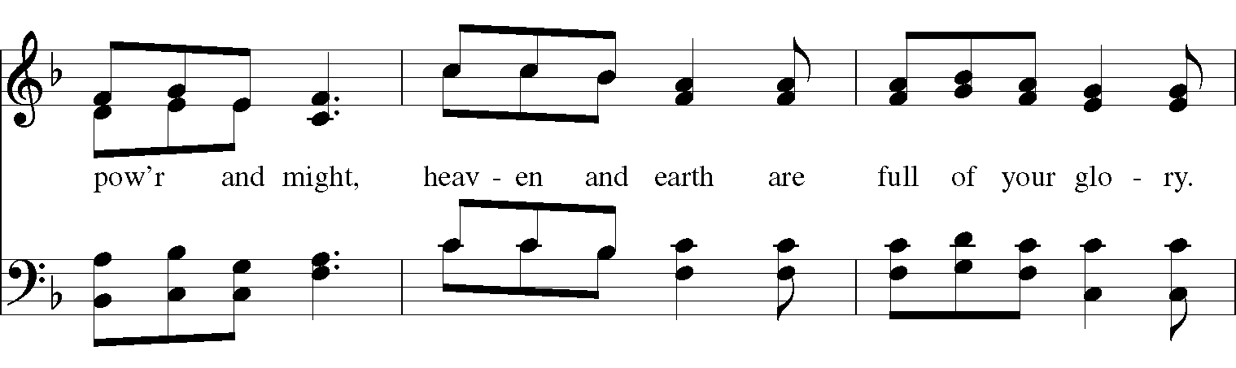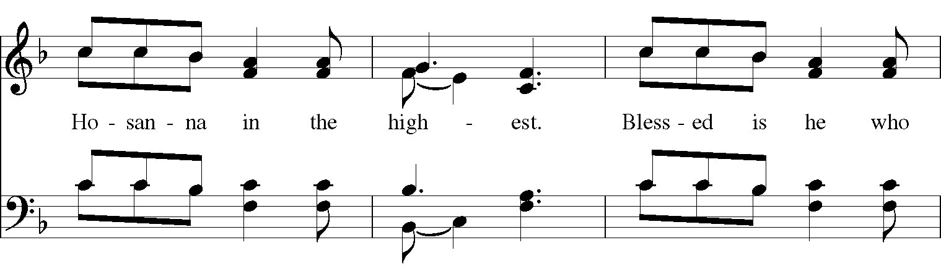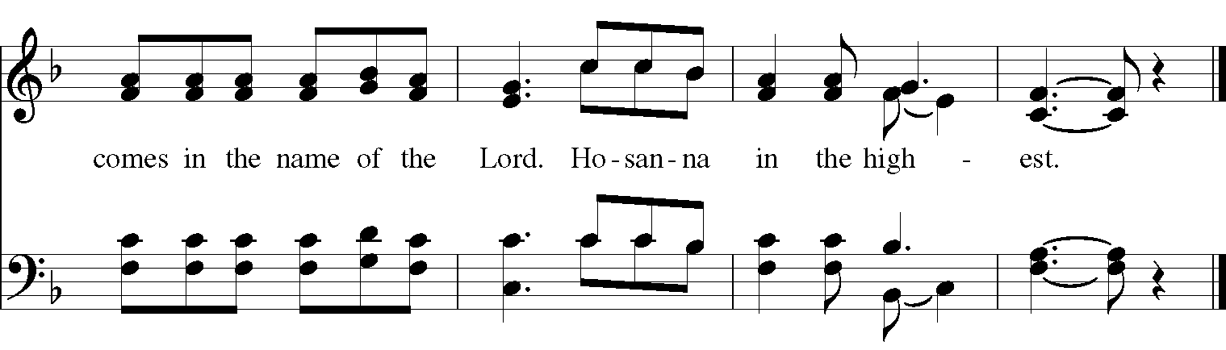
The people stand or kneel. The Presider continues
Glory and honor are yours, Creator of all, your Word has never been silent; you called a people to yourself, as a light to the nations, you delivered them from bondage and led them to a land of promise. Of your grace, you gave Jesus to be human, to share our life, to proclaim the coming of your holy reign and give himself for us, a fragrant offering. Through Jesus Christ our Redeemer, you have freed us from sin, brought us into your life, reconciled us to you, and restored us to the glory you intend for us.
We thank you that on the night before he died for us Jesus took bread, and when he had given thanks to you, he broke it, gave it to his friends and said: “Take, eat, this is my Body, broken for you. Do this for the remembrance of me.” After supper Jesus took the cup of wine, said the blessing, gave it to his friends and said: “Drink this, all of you: this cup is the new Covenant in my Blood, poured out for you and for all for the forgiveness of sin. Do this for the remembrance of me.” And so, remembering all that was done for us: the cross, the tomb, the resurrection and ascension, longing for Christ’s coming in glory, and presenting to you these gifts your earth has formed and human hands have made, we acclaim you, O Christ:
Dying, you destroyed our death.
Rising, you restored our life.
Christ Jesus, come in glory!
Send your Holy Spirit upon us and upon these gifts of bread and wine that they may be to us the Body and Blood of your Christ. Grant that we, burning with your Spirit’s power, may be a people of hope, justice and love. Giver of Life, draw us together in the Body of Christ, and in the fullness of time gather us with all your people into the joy of our true eternal home. Through Christ and with Christ and in Christ, by the inspiration of your Holy Spirit, we worship you our God and Creator in voices of unending praise.

. (Sing Once)

And now, as our Savior Christ has taught us, we are bold to pray:

People and Presider:
Our Father, who art in heaven, hallowed be thy Name, thy kingdom come, thy will be done, on earth as it is in heaven. Give us this day our daily bread. And forgive us our trespasses, as we forgive those who trespass against us. And lead us not into temptation,
but deliver us from evil. For thine is the kingdom, and the power, and the glory, for ever and ever. Amen.

The Breaking of the Bread
A period of silence is kept.

Alleluia. Christ our Passover is sacrificed for us;
Therefore let us keep the feast. Alleluia.

The following is sung:

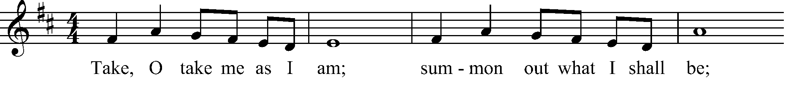
The Presider invites everyone to receive Communion.
The Gifts of God for the People of God. Take them in remembrance that Christ lived, died, and rose for you, and feed on him in your hearts by faith, with thanksgiving.
All who seek God and a deeper life in Christ are welcome to receive Holy Communion. At the direction of an usher, please exit your pew and receive the bread first, then proceed to the wine, and on to the water; then return to your seat. Communion may also be received in the bread alone, or in the bread and the wine with your small glass (one is provided if you need one). Please receive the bread first and consume it. If you are receiving the wine, please let the minister pour it into your glass, consume it, and then proceed to purify your glass with water, and consume that too. If you are at home, you are invited to receive Communion from the Reserved Sacrament at this time. If you would prefer to receive a blessing instead of Communion, simply cross your arms over your heart and the Presider will bless you. Gluten-free wafers are available; just ask the Presider for one.

Communion Hymn One Bread, One Body LEVAS 151

After Communion, the Presider says:
Let us pray.

Prayer after Communion
Presider and People:
Eternal God, you have graciously accepted us as living members of your Son our Savior Jesus Christ, and you have fed us with spiritual food in the Sacrament of his Body and Blood. Send us now into the world in peace, and grant us strength and courage to love and serve you with gladness and singleness of heart; through Christ our Lord. Amen.

Blessings and Thanksgivings

Presider: At this time, I invite you forward if you are celebrating a Birthday, Anniversary or any other blessing.

Presider: O God, our times are in your hands: Look with favor, we pray, on your servants, as they give thanks for your grace in their lives. Grant that they may grow in wisdom and strength, and increase their trust in your goodness in all the days to come; through Jesus Christ our Lord. Amen.

Announcements

Congregational Blessing (Sung once by all)
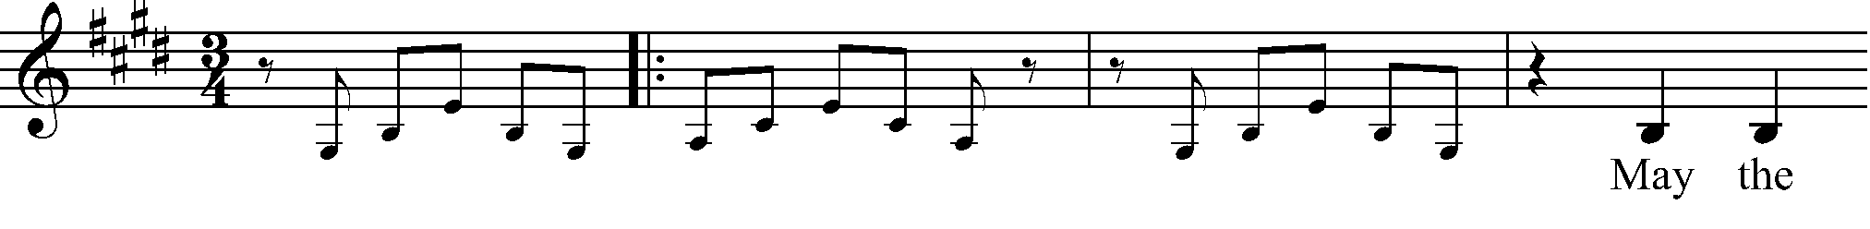
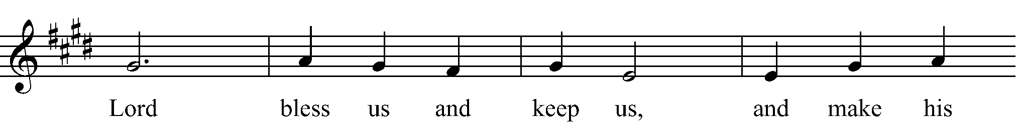
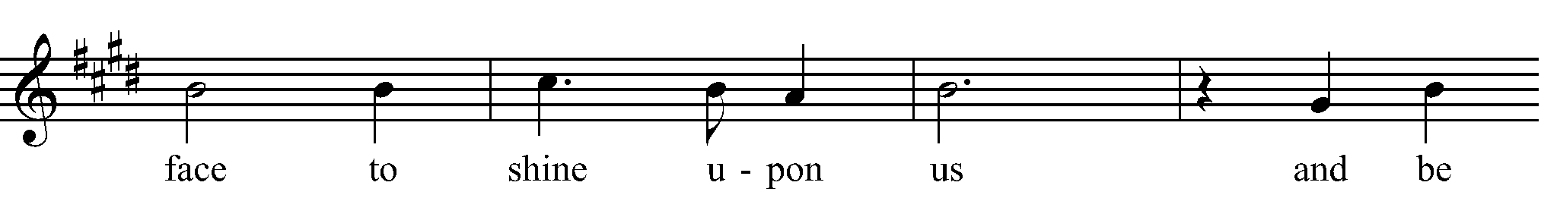
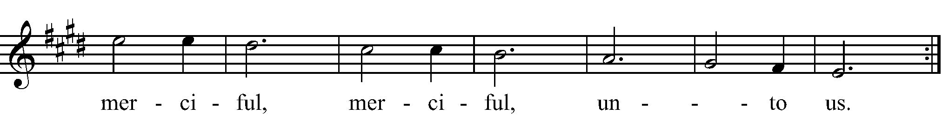

Post Communion Hymn He’s Got the Whole World in His Hands LEVAS 217

Dismissal

Presider: Alleluia! Let us go forth to love and serve the Lord.
Thanks be to God. Alleluia!

Created using riteworship. All musical selections reprinted with the permission of ritesong. All rights reserved. Used with permission. All scripture passages are taken from the New Revised Standard Version Bible, copyright 1989, Division of Christian Education of the National Council of the Churches of Christ in the United States of America. Used by permission. All rights reserved.

Happiness is knowing there is a God…………
And being on speaking terms with Him.

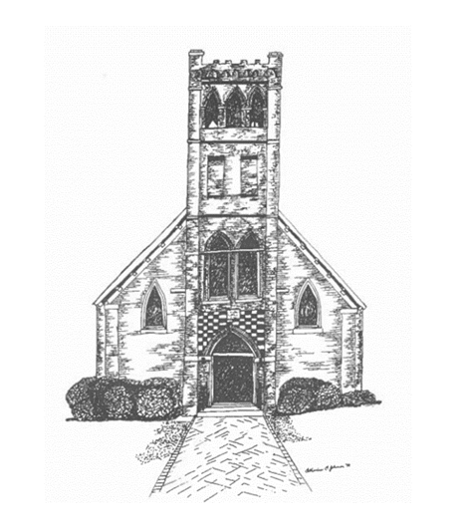

Trinity Mission
P.O. Box 187, 14515 Church Street, Upper Marlboro, MD 20773
Phone: (301)627-2636

The Rev. Dr. Peter M. Antoci, Vicar
The Rev. Dr. Thomas Bauer, Chaplain
Armand Peterson, Director of Music
Janet Ellmore, Musician
Leonard Blair, Screening

CALENDAR OF EVENTS
April 27, 2024 –May 15, 2024
The Episcopal Church in the Patuxent River Valley
April 27 | 7pm | Children’s Worship | Zoom
May 1 | 1-3pm | Crafts & Conversation | Trinity Upper Marlboro
May 1 | 7:30pm | Compline | Zoom
May 2 | 6-8pm | Girl Scouts | Trinity Upper Marlboro
May2 | 7-8pm | Book Study | Trinity Upper Marlboro
May 2 | 7:30pm | National Day of Prayer | Providence St. John Baptist Church, Upper Marlboro
May 4 | 7pm | Children’s Worship | Zoom
May 8 | 1-3pm | Crafts & Conversation | Trinity Upper Marlboro
May 8 | 7:30pm | Compline | Zoom
May 9 | 7-8pm | Book Study | Trinity Upper Marlboro
May 10 | 6pm | Parent’s Night Out | Cafe Trinity Upper Marlboro
May 11 | 7pm | Children’s Worship | Zoom
May 15 | 1-3pm | Crafts & Conversation | Trinity Upper Marlboro
May 15 | 7:30pm | Compline | Zoom
May 16 | 6-8 pm | Girl Scouts | Trinity Upper Marlboro
May 16 | 7-8pm | Book Study | Trinity Upper Marlboro
May 17 | 4-7pm | Spaghetti Dinner | St. Thomas’, Croom
May 17 | 6pm | Parent’s Night Out | Café Trinity Upper Marlboro
May 18 | 7pm | Children’s Worship | Zoom
May 22 | 1-3pm | Crafts & Conversation | Trinity Upper Marlboro
May 22 | 7:30pm | Compline | Zoom
May 23 | 7-8pm | Book Study | Trinity Upper Marlboro
May25 | 7pm | Children’s Worship | Zoom

